**MSP Rules of Engagement FAQ & Tenants Portal Instructions**

**(Internal Only Documentation)**

##### **Table of Contents:**

**Keywords and Explanations** 1

**What’s changing for 2020:** 2

**The Bottom Line:** 2

**FAQs:** 3

**Cloud Specific FAQs** 6

**How to create a “Dummy” ZORG** 7

**ZORG Registration Process** 8

Tenants Portal 8

**Keywords and Explanations**

**Call Home:** Zerto’s automatic billing process for MSPs. This is how Zerto tracks all replication for billing purposes within the MSP’s MRR model. It is directly related to our SaaS and Support platforms, which is enabled under the “About” section of the ZVM site settings. Note: this is a billing requirement for all MSP ZVMs, with an exception for high compliance sites that require “Dark Site” licenses and manual monthly billing.

**Bring Your Own License (BYOL):** Current Zerto end-customers with previously purchased Enterprise licenses, (specifically perpetual licenses), that shift their business model to leverage an MSP as their DR target. BYOL requires Zerto’s ECE licensing and an active Maintenance and Support contract to be utilized. Customer ZORG must be registered as ECC within the Tenants Portal (See registration on page 8).

**DRaaS:** Disaster Recovery as a Service.

**“Dummy” ZORG:** A Zerto Organization (ZORG) without a ZCC deployed. This is for Intra-Cloud DR (ICDR) or Private Cloud DRaaS architecture that does not require the ZCC’s added level of security/multitenancy. ZORGs are required for all MSP end-customers. A “Dummy” ZORG is a current workaround to track VM consumption via the resources used for replication, within non-traditional DRaaS.

**Intra-Cloud DR (ICDR):** Private Cloud MSP architecture with no end-customer access to the production or target ZVMs. Often leveraged as “white-glove” service by providers, who then manage the entire environment for the end-customers. Lack of access diminishes the need for Zerto’s security protocols like the ZCC.

**MRR:** Monthly Recurring Revenue.

**MSP:** Managed Service Provider, also known as Cloud Service Provider (CSP).

**Tenants Portal:** Within Zerto’s myzerto.com login portal. The Tenants Portal is located within the “Cloud Control” tab. Once on the Cloud Control page, the tabbed options for “Upgrade Manager” and “Tenants Portal” will be available at the top. Note: this is only available for myzerto.com logins that are associated with MSP accounts. (Further instructions on page 8).

**Xactly:** Zerto’s sales commission tool. Please speak to your respective manager for more information.

**ZCM:** The Zerto Cloud Manager. The ZCM is a manager of managers or the “single pane of glass” to manager all underlying ZVMs from in a multitenant environment. This is where an MSP can add their internal sites for end-customers to replicate to, setup service profiles, enable RBAC, and most of all, is where they create customer ZORGs. ZORG creation is also where MSP’s deploy Zerto Cloud Connectors (ZCCs) to segregate their environment for multitenancy in traditional DRaaS architecture. Within Intra-Cloud DR (ICDR), ZCCs are not required within the ZORG. Please see below for further information.

​

**ZORG:** A Zerto Organization (ZORG) is setup/deployed directly from the Zerto Cloud Manager (ZCM). ZORG settings allow for multitenancy via resource segregation at the hypervisor, which is defined within the ZORG itself. The associated Zerto Cloud Connector (ZCC) that is deployed from the ZORG settings, at the MSP’s target ZVM, regulates this segregation during the replication process.

**What’s changing for 2020:**

In support of our strategy to develop multiple routes-to-market, qualifying Participants in the Enterprise sales organization will receive quota attainment and commission for incremental VM sales fulfilled through one of our approved Gold or Platinum MSPs. The intention of this program is to compensate Enterprise sales teams in a manner commensurate to traditional license sales, but based on actual Zerto adoption, as evidenced by Zerto call home reporting.

**The Bottom Line:**

* Only incremental VMs will qualify for quota attainment and commission
* Only VMs fulfilled through one of our approved Gold or Platinum MSPs will qualify for quota attainment and commission
* Zerto will provide applicable sellers with quota attainment and commission based on qualifying call home data in his/her Territory on a monthly basis, based on the amount of per/VM credit listed in his/her Commission Letter
* Quota attainment and commission is entirely call home based and dependent upon MSP registration of the end-user entity (ZORG) via the Tenants Portal (i.e. the contracted number of VMs between the end user and the MSP is NOT a measurement of adoption and/or quota attainment and commission)
* Migration-only deals sold and delivered through our MSP route-to-market will NOT qualify for quota attainment and commission
* Call home usage driven from Bring Your Own License (“BYOL”) end users will not qualify for quota attainment and commission
* Call home usage driven from trial VM end users will not qualify for quota attainment and commission
* Creating a CRM opportunity is not required for compensation, nor will the level of end user engagement be considered and/or validated for quota attainment or commission. However, creating a CRM opportunity is encouraged for MSP pipeline tracking.

**FAQs:**

**1) What if the MSP does not register the end-customer ZORG?**

If the MSP does not register the ZORG, we won’t have a way to associate the VM growth to you. Every existing customer and new customer of an MSP needs to be registered by the MSP with a valid ZORG name that ties back to our call home data. (Page 8)

**2) Where do we see commission/deals/compensation?**

Compensation & attainment is targeted to be visible in Xactly at the beginning of Q2. During Q1, we will be updating our systems to be able to support this new compensation program.

Throughout Q1, our MSPs will be helping us with this process by registering their existing DRaaS customers, as well as any new customers that are signed. Capturing their customer data is an integral part of this compensation program.

**3) How do you see your compensation before Xactly is updated early Q2?**

We do not have visibility into compensation & attainment until the system updates are completed. This is targeted for early Q2. At this time, a true-up will be done in Xactly to compensate all individuals with incremental MSP VM growth in their account base throughout Q1.

**4) Do you need an open account to get paid?**

When the MSP registers a new DRaaS customer in the Tenants Portal, the workflow will create a Salesforce account for that customer if one does not already exist. The workflow will assign the account an owner based on our segmentation and region account assignment logic.

If an account already exists, the registration will populate a ZORG object within the account. Account ownership determines compensation and attainment against the ZORG usage.

**5) What if I have a DRaaS opportunity that I was working in 2019 that has now started to deploy in 2020?**

Once the MSP registers the ZORG in the Tenants portal, the workflow will create a ZORG object in Salesforce, which will then be populated each month with call home data. Compensation and attainment will now be determined on the account owner of the end user and is not tied to an opportunity, but rather to the call home usage on the ZORG.

However, you can still move your DRaaS opportunity into the Submitted to Finance stage once the contract is signed. Sales Operations will move DRaaS opportunities into Closed Won when the deal starts deploying by showing call home usage within the ZORG.

**6) What do we do with existing DRaaS opps that have already been created?**

Compensation will be determined based on the account owner where the ZORG exists.

Existing DRaaS opportunities can be kept in the system for tracking and status updates. The Cloud AEs and management will utilize DRaaS opportunities for tracking the MSP pipeline. Once the first VM is deployed with the MSP, the DRaaS opportunity will be moved to the Closed Won stage with the amount being the projected VM amount multiplied by the DRaaS rate from your commission plan. This information will be used by the Cloud team to help manage their overall MSP forecast.

However, a DRaaS opportunity is not required to earn compensation and quota attainment.

**7) Do DRaaS deals have an implementation timeline for compensation? I.E. Are the VMs required to be onboarded within a specific timeframe for compensation?**

No, there is no time constraint. Compensation and attainment will be earned after the call home usage is populated within the ZORG.

The amount of time needed to implement and deploy a new customer is ultimately determined by the MSP and their customer. Periodical touchpoints with the Cloud team will help notify them of your commissioned deal and the continued pursuit for its onboarding, as it is in all our best interest.

**8) Which MSPs are good Hyper-V/Azure/AWS DRaaS providers?**

Zerto can replicate any-to-any of our supported platforms. Unless an end-customer absolutely demands that they replicate Hyper-V SCVMM to Hyper-V SCVMM, this should be irrelevant. Additionally, most MSPs provide “white-glove” services and could fulfill the platform request through their contract negotiations with the end-customer.

**9) How should we engage in the DRaaS sales cycle? This depends on how the deal originated, see below:**

1. **Originated from a lead through marketing**

If your deal came through a lead from Zerto’s marketing department, you can engage with the customer as you would in any other deal. If the customer decides to purchase Zerto through one of our MSPs, feel free to introduce the end user to one or more of our gold and platinum partners. Be sure to loop in the appropriate Cloud AE so they are aware of the deal, as well. Continue to work with the end user and the chosen MSP throughout the sales cycle.

If the end user already has a preferred MSP, and it is not a gold or platinum partner, you can transfer the deal to the appropriate Cloud AE to run with.

1. **Pipeline shared with Zerto from the MSP (Gold or Platinum)**

Coordinate with the MSP’s sales rep and the Zerto Cloud AE to determine where the deal is in the sales cycle. Offer to be of assistance to the MSP’s sales rep for any questions, technical clarifications, or demos that may be needed.

1. **Originally an enterprise deal that switched to DRaaS**

If the end user does not have a chosen partner, introduce them to one or more of our gold and platinum partners. Be sure to loop in the appropriate Cloud AE for awareness. Continue to work with the end user and the chosen MSP throughout the sales cycle.

If the end user already has a preferred MSP, and it is not a gold or platinum partner, you can transfer the deal to the appropriate Cloud AE to run with.

**10) Are the DRaaS providers (MSPs) still going to be a version behind?**

It is standard for MSPs to not incorporate any type of “bleeding edge” technologies in their infrastructure, let alone Zerto. In multitenant environments, one bug/issue could affect hundreds of end-customers. With Zerto, this often means that the MSP will wait until the u2 or u3 version is released. MSPs will also have testing stages to prove product stability before they implement a software version into their production environment. But there are always exceptions. Some MSPs may be forced to move to the newest version of Zerto, especially if our newest features are required by their end-customers.

**More importantly**, while the MSP will run their Zerto environment a platform version behind, they do not enforce their customers to do the same. It is common to see end-customers with the newest version of Zerto and replicating to the previous platform version at the MSP. In this scenario, if there is **a bug/issue on the newest version, only the end customer running said version is affected.**

**11) Are Zerto sales reps paid differently depending on the license SKUs that the MSP sells? I.E. Standard Cloud vs. O2M/LTR Cloud?**

No, a VM is worth the same amount regardless of whether standard or O2M/LTR has been sold.

If a current customer of an MSP purchases an expansion, the seller will be compensated on the incremental expansion VMs. A decrease in VM usage from an existing (2019 and earlier) MSP customer will not negatively affect the seller’s compensation and attainment.

Migration deals and customers with existing licenses are excluded from compensation and attainment.

**12) Who are the current Gold and Platinum MSPs with Zerto?**

Here is a link to a Salesforce report with all our current Gold and Platinum level partners. Note that the list can change throughout the year as MSPs hit certain MRR thresholds:

<https://zerto.my.salesforce.com/00O2I000007gdS5>

**13) Where can I see the DRaaS Pipeline and who creates opportunities?**

For Enterprise sales members, there will be a tile on the ZWeek Dashboard showing the DRaaS pipeline for your specific region. In terms of opportunity creation, the origination of the lead determines who will create the opportunity.

If the lead is:

* Marketing sourced: the SDR team will create an opportunity and assign it to the appropriate salesperson.
* Sales sourced: the appropriate salesperson can create the opportunity.
* Partner sourced: then the Cloud AE will own the opportunity creation. However, it will still be owned by an Enterprise AE or ISR.

In all cases, please be sure to add a cloud provider to your DRaaS opportunity.

**Cloud Specific FAQs**

**14) The MSP uses Private Cloud deployments (ICDR) without ZORGs or ZCCs between sites. In this scenario, how does the MSP register an end-customer?**

The MSP will be required to have a ZCM deployed and must create what are called “Dummy” ZORGs. For this situation, the “Dummy” ZORG is one that is created without a ZCC and only contains the resources used by the customer’s VM replication. Simply create a ZORG on the ZCM with the customer’s name or MSP’s desire naming convention and add the resources used between both sites, strictly the ones used for this customer’s VM replication. All resources are required to ensure that every VM is tracked accordingly.

**15) The MSP uses Private Cloud deployments (ICDR) and they want to limit the administrative time it takes to create ZORGs for customer/deal tracking. Can I deploy a “Dummy” ZORG without adding the resources being used by the VMs?**

No. Without the resources, Zerto does not have a way to track the onboarding of VMs and their replication in association to the ZORG/end-customer. Therefore, we will not see the deployment of the VMs that are associated with the DRaaS deal, and the Enterprise rep. will not be paid. VM growth will show as organic growth and will be unassociated with a direct end-customer.

**16) What if the MSP strictly uses Public Cloud (Azure/AWS), which does not allow resource allocation on the ZORG? How can we track the VM onboarding?**

Currently, replication to the Public Cloud is not common within our Gold and Platinum MSPs. Larger MSPs historically saw Public Cloud as competition and are only beginning to have adoption conversations now. Public Cloud adoption is more common within small/medium MSPs who want to be competitive but are irrelevant for DRaaS compensation (not gold/platinum).

Zerto has a Feature Request to overcome this issue by setting the entire ZVM/ZCA as a resource within the ZORG. Please take the time to review and vote on ZVRCSP-I-115 “Allow for an entire ZVM or ZCA site to be added to a ZORG as a resource”.

**17) The MSP refuses to deploy ZORGs because they have too many end-customers in place already/don’t have the time/or any other excuse. How do I enforce the MSP to create ZORGs?**

Our current EULA clearly states that ZORGs are required. This should be enforced by the Cloud Account Executive.

**18) Are there any Salesforce reports available to track ZORGs by MSP and by Account?**

Salesforce links:

[All ZORGs by MSP](https://zerto.my.salesforce.com/00O0G000007Q7IQ)

[Gold & Platinum MSP ZORGs](https://zerto.my.salesforce.com/00O2I0000078AWV)

**How to create a “Dummy” ZORG**

**For ICDR Environments with no ZCCs:**

1. Within the Zerto Cloud Manager (ZCM), use the “Add” button at the right-hand side of the Organizations tab to create a ZORG.

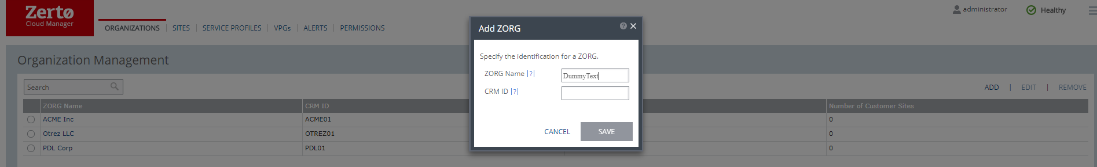

1. Once saved, enter the ZORG and right click on the applicable resource tab (vCenter or vCD).

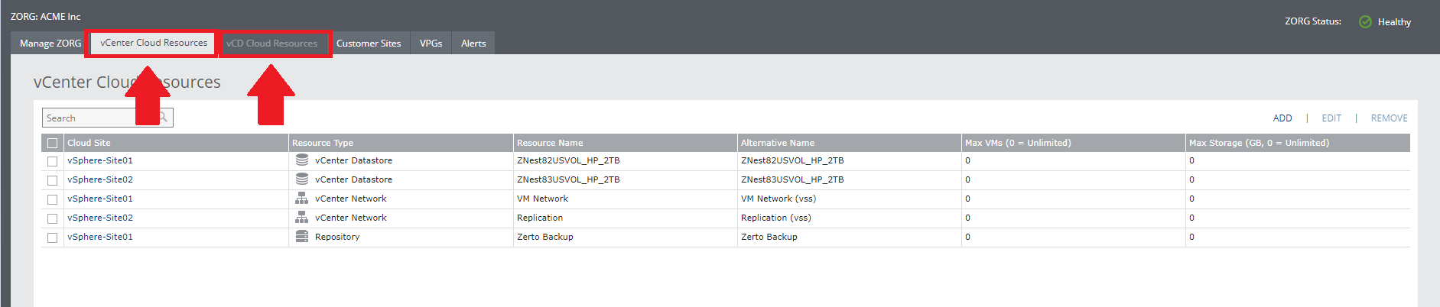

1. Add all the resources used for replication on both ZVMs/Hypervisors (production and target). Note: ALL resources used for replication are required. Adding a “blanket” of resources across the board will allow for replication flexibility. ICDR’s lack of resource security requirements will not cause an issue with overlapping resources.

**ZORG Registration Process**

Tenants Portal

All Zerto Managed Service Providers (MSPs) will be required to register every end-customer ZORG within the MyZerto Tenants Portal. This allows the MSP to regulate the use of higher priced features like O2M and LTR, while also flagging VMs that count towards an end customer’s previously purchased license with Zerto, under the Bring-Your-Own-License model (BYOL). The Tenants Portal is also where the MSP can store added information about their end-customer’s ZORG, all of which is accessible via the Zerto Android/iPhone App or the MyZerto web portal.

Requirements for “Tenants”

In ZVM:

1. ZVM must have “Enable Zerto SaaS applications” enabled under the “About” section of Zerto site settings

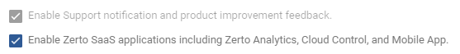

1. ZVM must have port 443 open to <https://zerto-mobile-data.zerto.com>
2. ZVM version 5.5u4 or higher
3. User must be registered user in MyZerto with their work email domain address

How to Access “Tenants”

1. Log into MyZerto (www.zerto.com/myzerto)
2. Select “Cloud Control” from the navigation bar – will open in a new tab



1. Select “Tenants”



How to “Add” a new “ZORG” in “Tenants”

1. Click “Add” in the top right

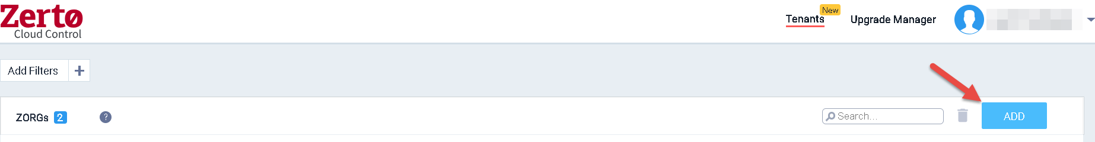

1. Select the appropriate ZORG by clicking on the “ZORG Name” field – note that typing in this field will filter the list.

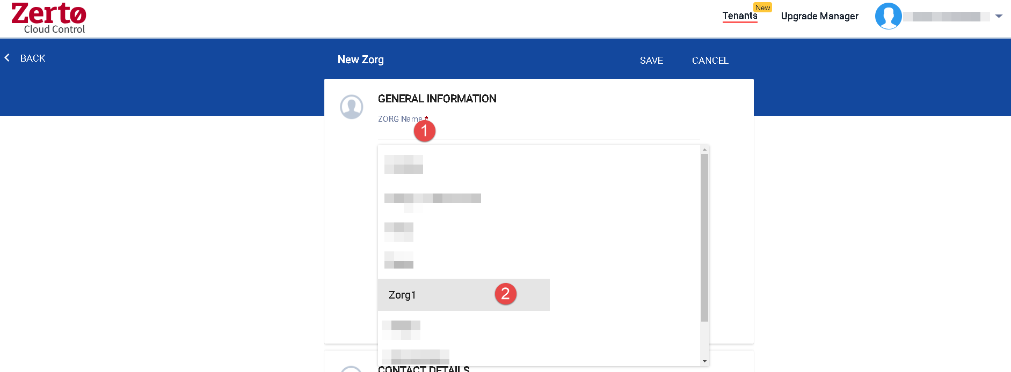

1. Fill in the other required fields.

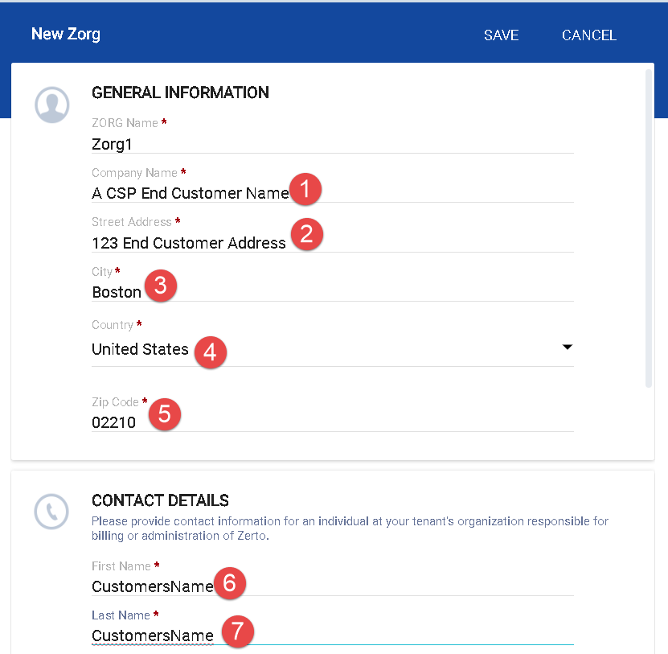

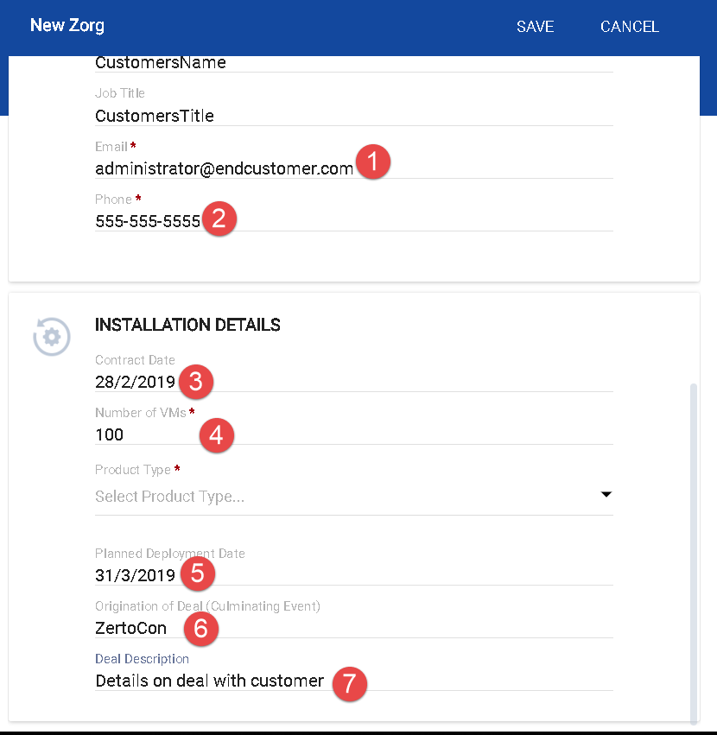

1. Select a product type:
   1. Software Subscription: Zerto Virtual Replication (ZVR) provides protection for virtual machines in Service Provider site.
      1. **Usage for this ZORG is billed at the provider’s regular rate. (list $30)**
   2. Multi Cloud: ZVR Multi-Cloud (MC) enables one-to-many, simultaneous protection and recovery of VMs within on-premise and multiple Service Provider sites, for up to 3 sites
      1. **Usage for this ZORG is billed at the provider’s premium rate. (list $39)**
   3. Enterprise Cloud Customer: Enterprise Cloud Customers (ECC) with an existing perpetual ECE license and a valid maintenance and support agreement for such a license with Zerto, who will now be using a Service Provider for replication for one of their sites
      1. **Usage up to the enterprise customer’s ECE license amount for this ZORG is billed at $0.**
   4. Migration:
      1. **Migration is to be used for customer workloads that will be migrating to, from, or within your cloud sites. Once the customer's migration is complete, the ZORG's product type should be updated to better reflect their ongoing services.**

|  |
| --- |
|  |

1. Click “Save”

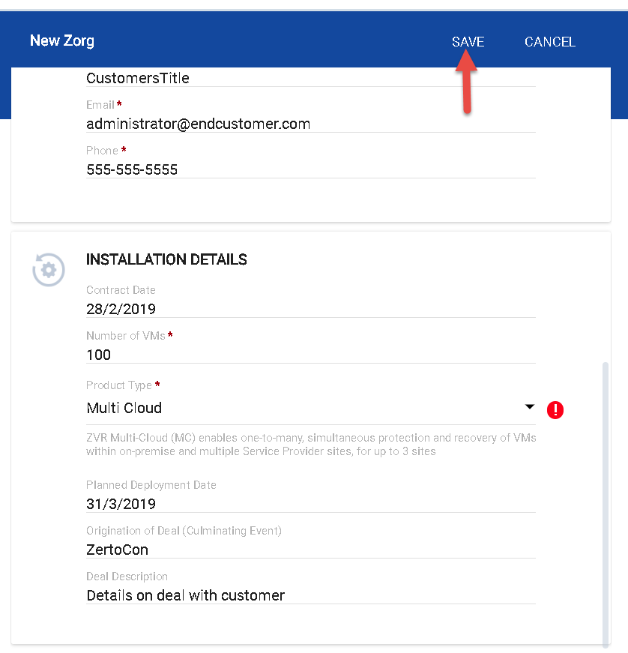

How to edit an existing “ZORG” in “Tenants”

1. Click the link for the “ZORG” you wish to edit

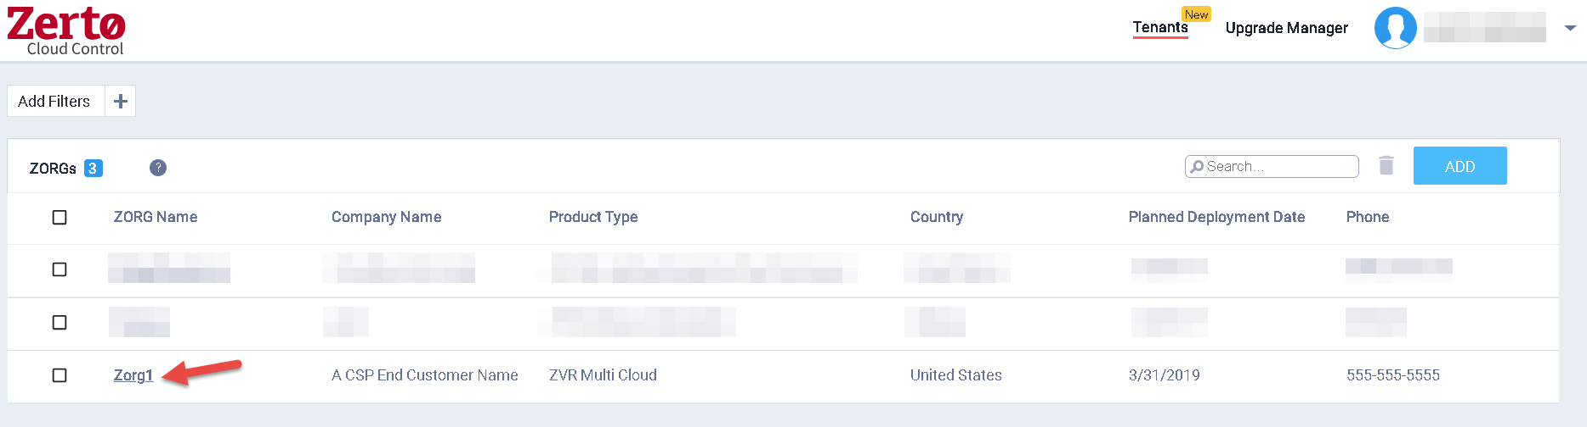

1. Click the “Edit” pencil icon in the top right

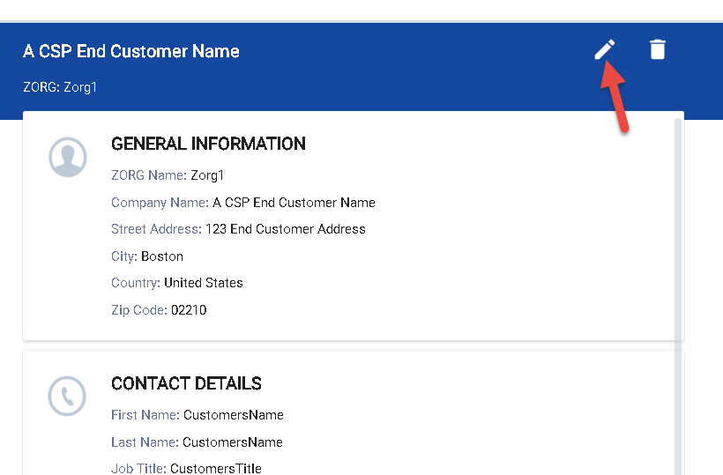

1. Make the desired changes and click “Save”

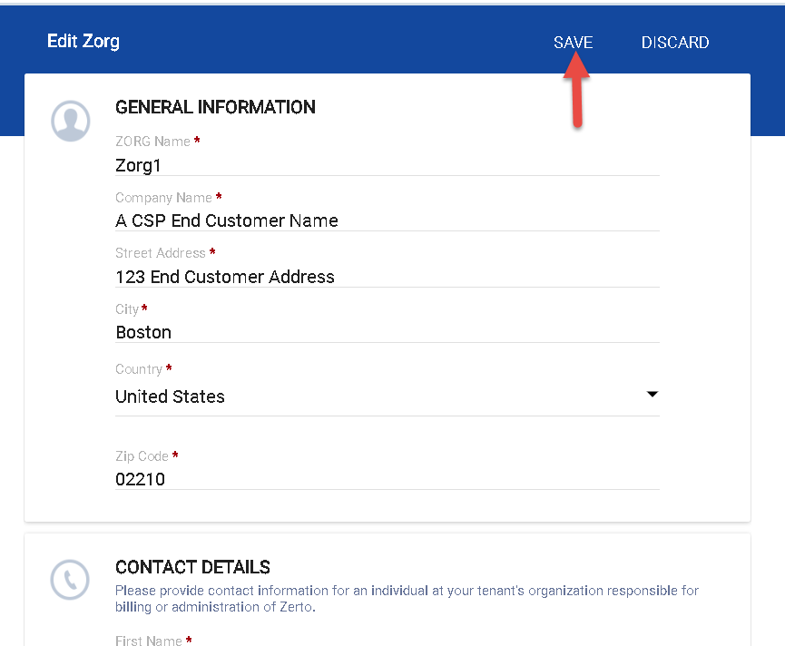

How to Delete a “ZORG” in “Tenants”

Method 1

1. Select the check box for the desired ZORG and click the “Delete” trash can icon

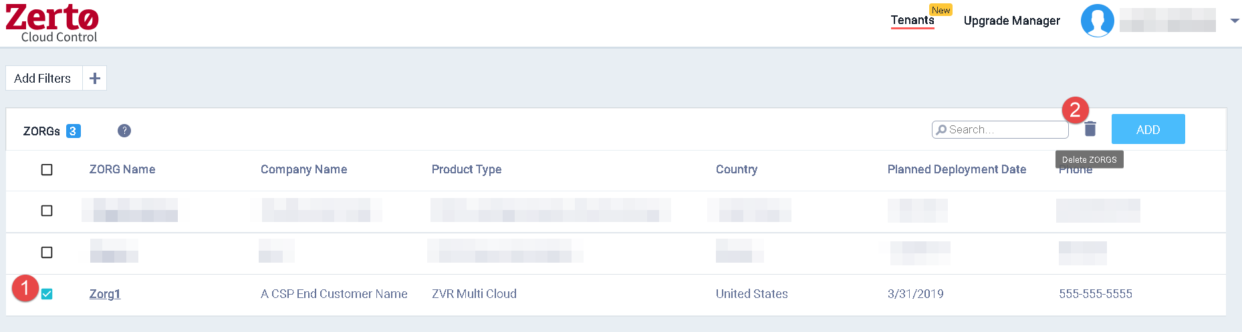

Method 2

1. Click the link for the “ZORG” you wish to delete
2. Click the “Delete” trash can icon in the top right

